Experiment 10
Aim
Implement Community Detection / Clustering algorithm (e.g. Clique Percolation, Louvain method) for social media data for any business use case.
Theory
The Clique Percolation Method (CPM) is a community detection algorithm used to identify overlapping communities in a graph. Unlike traditional methods, it allows a node to belong to multiple communities.
A k-clique is a complete subgraph containing k nodes, where every pair of nodes is connected. Two k-cliques are considered adjacent if they share k − 1 nodes. By connecting adjacent cliques, the algorithm identifies communities as groups of interconnected cliques.
Steps:
- Identify all k-cliques in the graph.
- Find adjacent cliques sharing k − 1 nodes.
- Connect adjacent cliques to form clique clusters.
- Combine the nodes in each cluster to obtain overlapping communities.
Example
Consider two 3-cliques (triangles):
- Clique 1: A, B, C
- Clique 2: B, C, D
Both cliques share nodes B and C, i.e., k − 1 = 2 nodes. Therefore, they are adjacent and form a single community: {A, B, C, D}.
If another triangle exists, such as C, D, E, it also joins the same community because it shares two nodes with the second triangle.
Result: The algorithm detects communities based on overlapping cliques, and shared nodes can belong to multiple communities.
Dataset
The experiment uses the ego-Facebook dataset from the Stanford Network Analysis Project (SNAP), collected from real Facebook users by McAuley and Leskovec (2012). It contains 4,039 anonymized users and 88,234 friendships, organized into 10 ego networks, along with the friend circles that users defined themselves. Ego network 3980 is analyzed here, with 52 users, 146 friendships, and 17 circles. Source: https://snap.stanford.edu/data/ego-Facebook.html
Business Use Case: Audience Segmentation for Targeted Marketing
A brand can use social network structure to plan a marketing campaign:
- Communities act as audience segments, since tightly connected users are likely to see and share the same content.
- The best-connected user in a community is a candidate seed influencer for reaching that segment.
- Overlapping users are bridge users, who can carry a campaign from one segment to another.
- Periphery users belong to no community and are reached through broader campaigns.
- The value of k sets how tightly connected a segment must be, with higher values giving smaller and more cohesive segments.
Execution
#cpm_facebook.py
"""Clique Percolation for audience segmentation on a real Facebook ego network (SNAP ego-Facebook).

usage: python cpm_facebook.py <facebook-dir> [ego-id]
"""
import os
import sys
from collections import defaultdict
from itertools import combinations

import matplotlib
matplotlib.use("Agg")
import matplotlib.patches as mpatches
import matplotlib.pyplot as plt
import networkx as nx
import numpy as np
from networkx.algorithms.community import k_clique_communities

PALETTE = ["#2a78d6", "#eb6834", "#1baf7a", "#eda100", "#e87ba4", "#008300", "#6250d6", "#e34948"]
OVERLAP = "#1a1a19"
PERIPHERY = "#e4e3df"
EDGE = "#c9c8c2"
INK = "#0b0b0b"
K_VALUES = (3, 4, 5)
SEGMENT_K = 4

def load_ego_network(base, ego):
G = nx.read_edgelist(os.path.join(base, f"{ego}.edges"), nodetype=int)
circles = {}
with open(os.path.join(base, f"{ego}.circles")) as f:
for line in f:
name, *members = line.split()
circles[name] = {int(m) for m in members}
return G, circles

def manual_cpm_step_by_step(G, k):
# Step 1: All cliques of size >= k, then extract all combinations of size k
cliques_k = set()
for c in nx.find_cliques(G):
if len(c) >= k:
for sub_c in combinations(c, k):
cliques_k.add(frozenset(sub_c))
cliques_k = list(cliques_k) # Unique k-cliques
# Step 2: Build overlap graph
clique_graph = nx.Graph()
clique_graph.add_nodes_from(cliques_k)
for i in range(len(cliques_k)):
for j in range(i + 1, len(cliques_k)):
if len(cliques_k[i] & cliques_k[j]) == k - 1:
clique_graph.add_edge(cliques_k[i], cliques_k[j])
# Step 3 & 4: Connected components to communities
communities = [set().union(*comp) for comp in nx.connected_components(clique_graph)]
# Sort communities by size descending, then smallest node id
communities.sort(key=lambda s: (-len(s), min(s)))
return cliques_k, clique_graph, communities

def analyze_cpm(G, k_values=K_VALUES):
results = {}
for k in k_values:
cliques_k, clique_graph, communities = manual_cpm_step_by_step(G, k)
# Verify with NetworkX built-in
nx_communities = {frozenset(c) for c in k_clique_communities(G, k)}
verified = nx_communities == {frozenset(c) for c in communities}
# Node membership counts
membership = defaultdict(list)
for idx, comm in enumerate(communities, 1):
for node in comm:
membership[node].append(idx)
overlapping = {n: comms for n, comms in membership.items() if len(comms) > 1}
unassigned = set(G.nodes()) - set(membership)
results[k] = {
"communities": communities,
"overlapping_nodes": overlapping,
"unassigned_nodes": unassigned,
}
print(f"\nk = {k}: {len(cliques_k)} k-cliques, {clique_graph.number_of_edges()} clique adjacencies, "
f"{len(communities)} communities")
for idx, comm in enumerate(communities, 1):
print(f" Community {idx} (size {len(comm)}): {sorted(comm)}")
print(f" Overlapping users: {sorted(overlapping)}")
print(f" Periphery (no community): {len(unassigned)}")
print(f" Matches NetworkX k_clique_communities: {verified}")
return results

def business_report(G, circles, result):
"""Treat communities as audience segments for a targeted marketing campaign."""
print(f"\nAudience segments for targeted marketing (k = {SEGMENT_K})")
print(f" {'Segment':<9}{'Users':<7}{'Seed influencer':<17}{'Links in segment':<18}{'Closest circle':<16}Jaccard")
for idx, comm in enumerate(result["communities"], 1):
degree = dict(G.subgraph(comm).degree())
seed = max(sorted(degree), key=degree.get)
name, members = max(circles.items(), key=lambda kv: (len(comm & kv[1]) / len(comm | kv[1]), kv[0]))
jaccard = len(comm & members) / len(comm | members)
print(f" {idx:<9}{len(comm):<7}{seed:<17}{degree[seed]:<18}{name:<16}{jaccard:.2f}")
print(" Bridge users for cross-segment campaigns:")
for node, comms in sorted(result["overlapping_nodes"].items()):
print(f" User {node} connects segments {comms}")
print(f" Users outside every segment (reach through broad campaigns): {len(result['unassigned_nodes'])}")

def spread_nodes(pos, min_dist=0.125, rounds=400):
# Push apart any two nodes closer than min_dist so that their labels stay readable
nodes = sorted(pos)
for _ in range(rounds):
moved = False
for a, b in combinations(nodes, 2):
delta = pos[a] - pos[b]
dist = float(np.hypot(*delta))
if dist < min_dist:
direction = delta / dist if dist > 0 else np.array([1.0, 0.0])
shift = direction * (min_dist - dist) / 2
pos[a], pos[b] = pos[a] + shift, pos[b] - shift
moved = True
if not moved:
break
return pos

def fixed_layout(G):
# Main component fills the canvas; the small disconnected groups sit in a column on the right
components = sorted(nx.connected_components(G), key=lambda c: (-len(c), min(c)))
pos = spread_nodes(nx.kamada_kawai_layout(G.subgraph(components[0]), scale=1.0))
y = -0.95
for comp in reversed(components[1:]):
radius = 0.09 + 0.018 * len(comp)
ring = nx.circular_layout(G.subgraph(comp), scale=radius, center=(1.42, y + radius))
pos.update(ring)
y += 2 * radius + 0.16
return pos

def visualize_cpm(G, results, out_dir):
os.makedirs(out_dir, exist_ok=True)
# Pre-compute fixed layout for consistent visual comparison
pos = fixed_layout(G)
for k, res in results.items():
fig, ax = plt.subplots(figsize=(8.6, 6.4), dpi=200)
overlapping = res["overlapping_nodes"]
nx.draw_networkx_edges(G, pos, edge_color=EDGE, width=0.8, ax=ax)
# Plot unassigned nodes
nx.draw_networkx_nodes(G, pos, nodelist=sorted(res["unassigned_nodes"]), node_color=PERIPHERY,
edgecolors="#8a8984", linewidths=0.8, node_size=430, ax=ax)
# Plot communities
handles = []
for idx, comm in enumerate(res["communities"]):
color = PALETTE[idx]
single = sorted(n for n in comm if n not in overlapping)
nx.draw_networkx_nodes(G, pos, nodelist=single, node_color=color, edgecolors="white",
linewidths=1.2, node_size=500, ax=ax)
handles.append(mpatches.Patch(facecolor=color, label=f"Comm {idx + 1} (n={len(comm)})"))
# Plot overlapping nodes with a distinct marker
if overlapping:
nx.draw_networkx_nodes(G, pos, nodelist=sorted(overlapping), node_color=OVERLAP, node_shape="s",
edgecolors="white", linewidths=1.2, node_size=500, ax=ax)
handles.append(mpatches.Patch(facecolor=OVERLAP, label=f"Overlap ({len(overlapping)})"))
handles.append(mpatches.Patch(facecolor=PERIPHERY, edgecolor="#8a8984",
label=f"Periphery ({len(res['unassigned_nodes'])})"))
light_labels = {n: n for n in overlapping}
dark_labels = {n: n for n in G.nodes() if n not in overlapping}
nx.draw_networkx_labels(G, pos, labels=dark_labels, font_size=5.5, font_color=INK, ax=ax)
nx.draw_networkx_labels(G, pos, labels=light_labels, font_size=5.5, font_color="white", ax=ax)
count = len(res["communities"])
ax.set_title(f"k = {k} ({count} Communit{'y' if count == 1 else 'ies'})", color=INK, fontweight="bold", fontsize=11)
ax.legend(handles=handles, loc="upper right", fontsize=7, frameon=True, framealpha=0.95)
ax.set_axis_off()
fig.tight_layout()
path = os.path.join(out_dir, f"cpm_k{k}.png")
fig.savefig(path, facecolor="white")
plt.close(fig)
print(f"Saved {path}")

if __name__ == "__main__":
base = sys.argv[1]
ego = sys.argv[2] if len(sys.argv) > 2 else "3980"
G, circles = load_ego_network(base, ego)
print(f"SNAP ego-Facebook, ego network {ego}")
print(f"Users: {G.number_of_nodes()} Friendships: {G.number_of_edges()} "
f"Connected components: {nx.number_connected_components(G)} User-defined circles: {len(circles)}")
print(f"Largest clique: {max(len(c) for c in nx.find_cliques(G))} users")
results = analyze_cpm(G)
business_report(G, circles, results[SEGMENT_K])
print()
visualize_cpm(G, results, "output")

Output
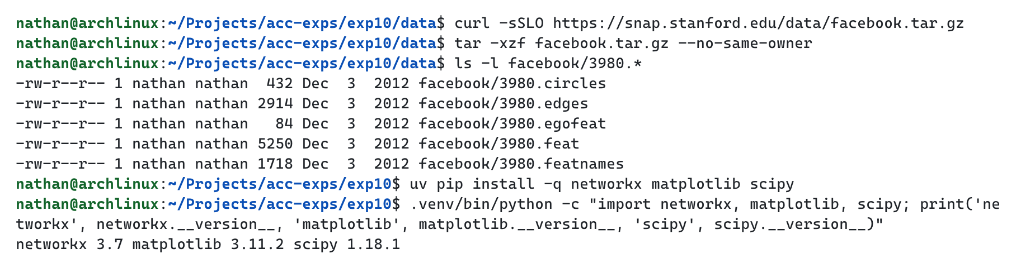

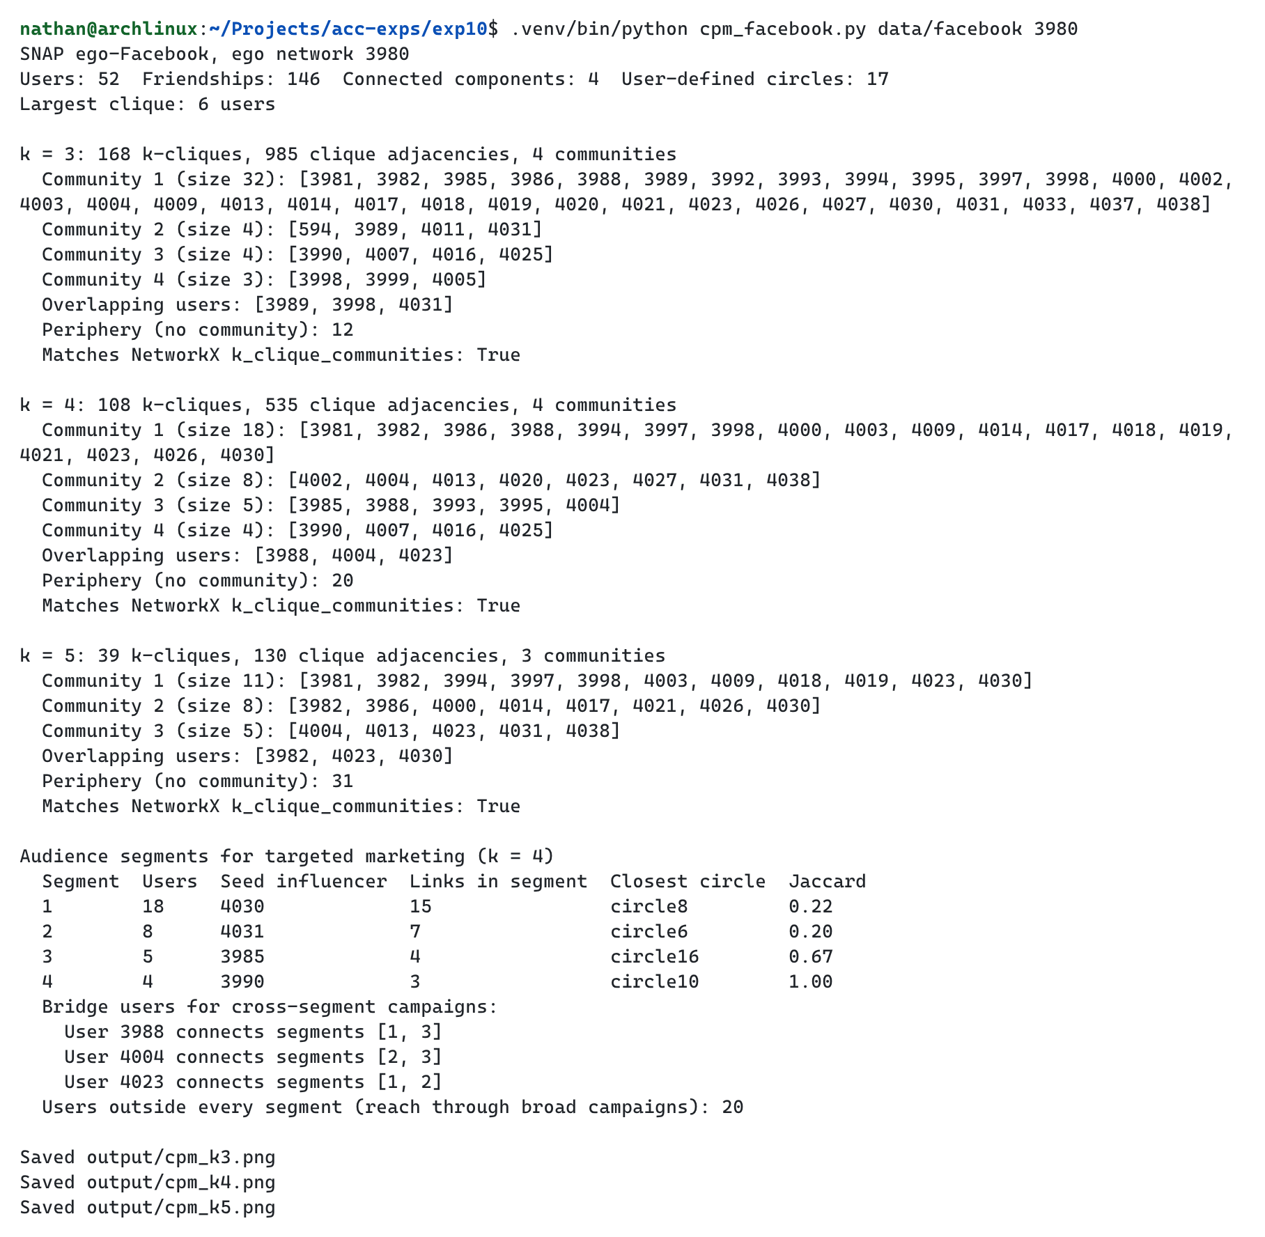

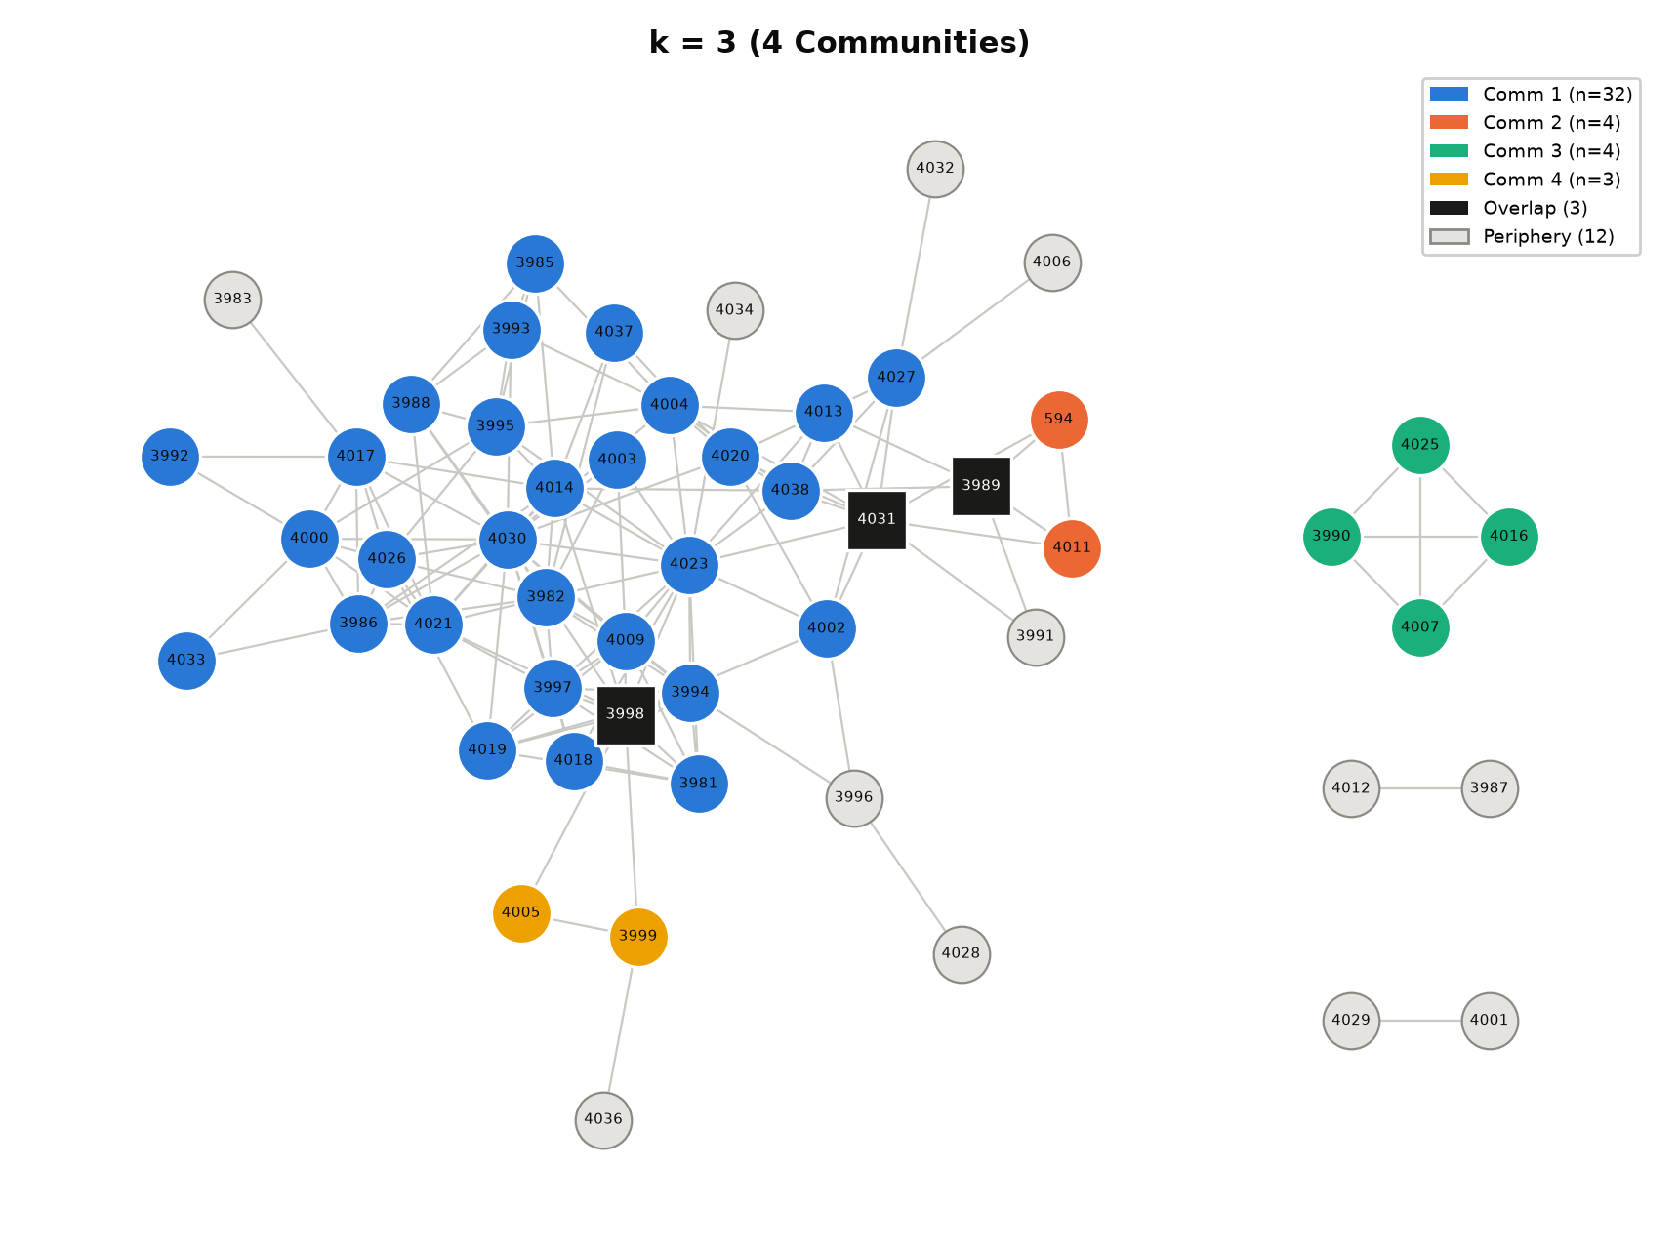

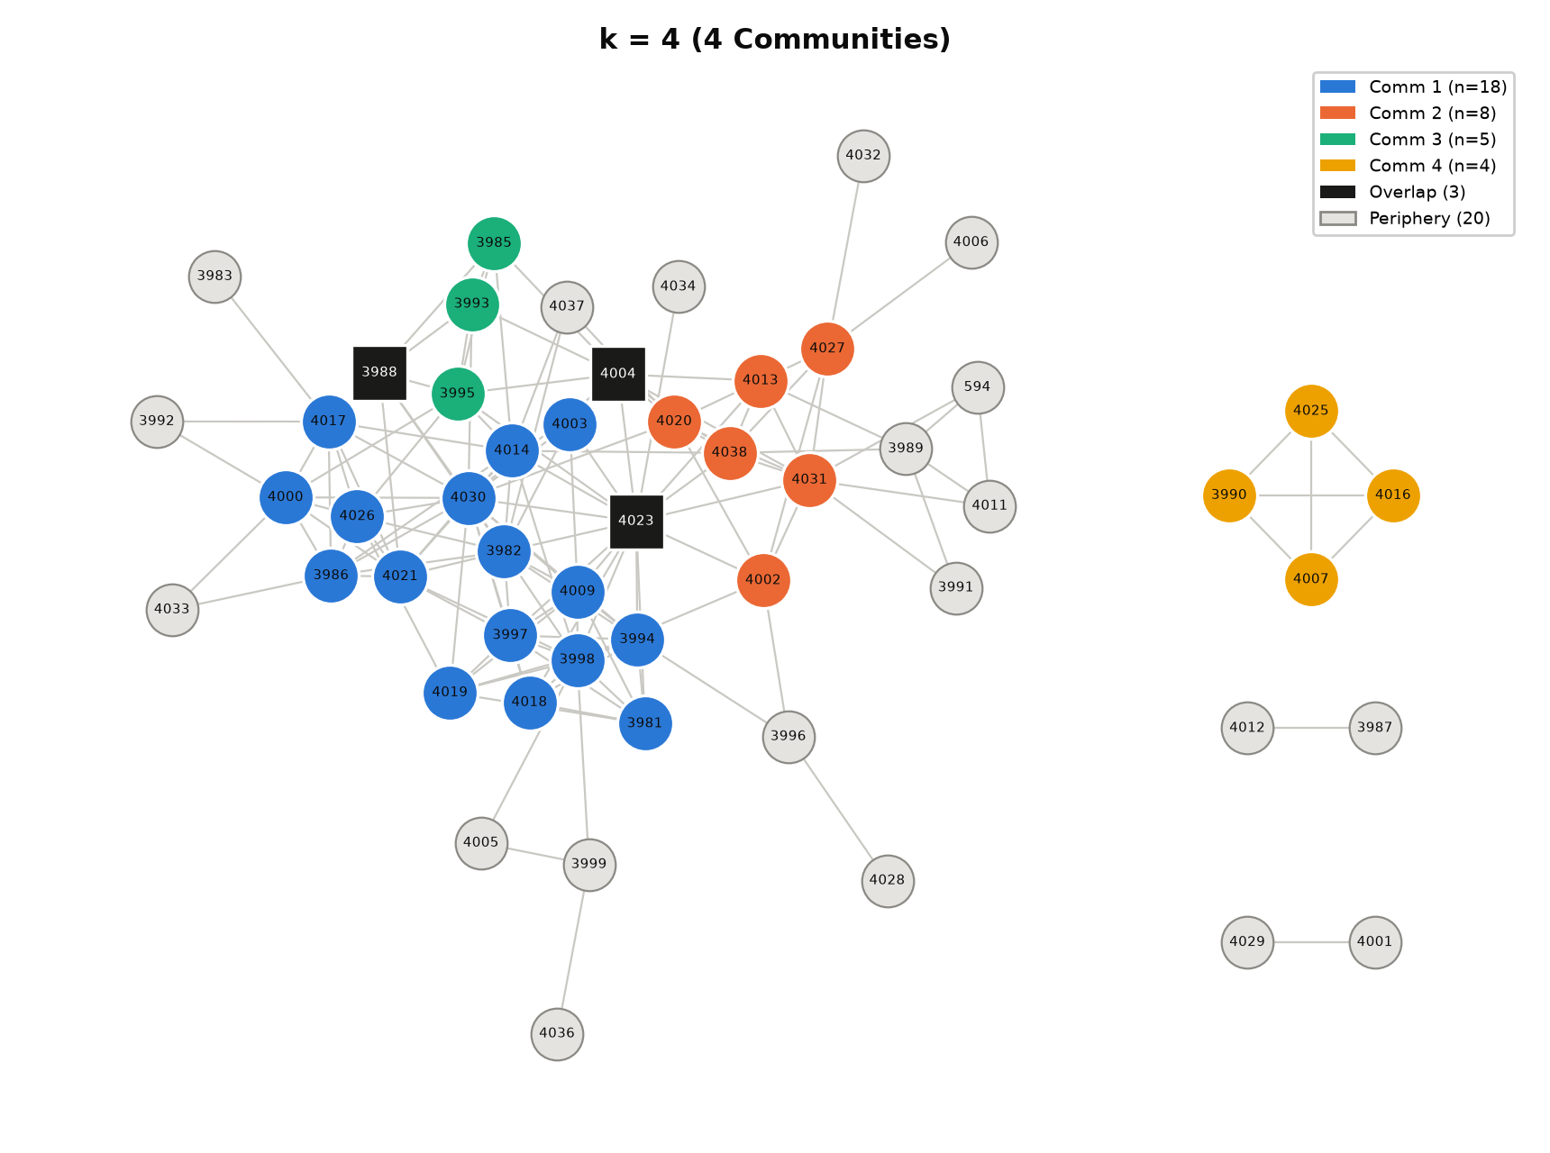

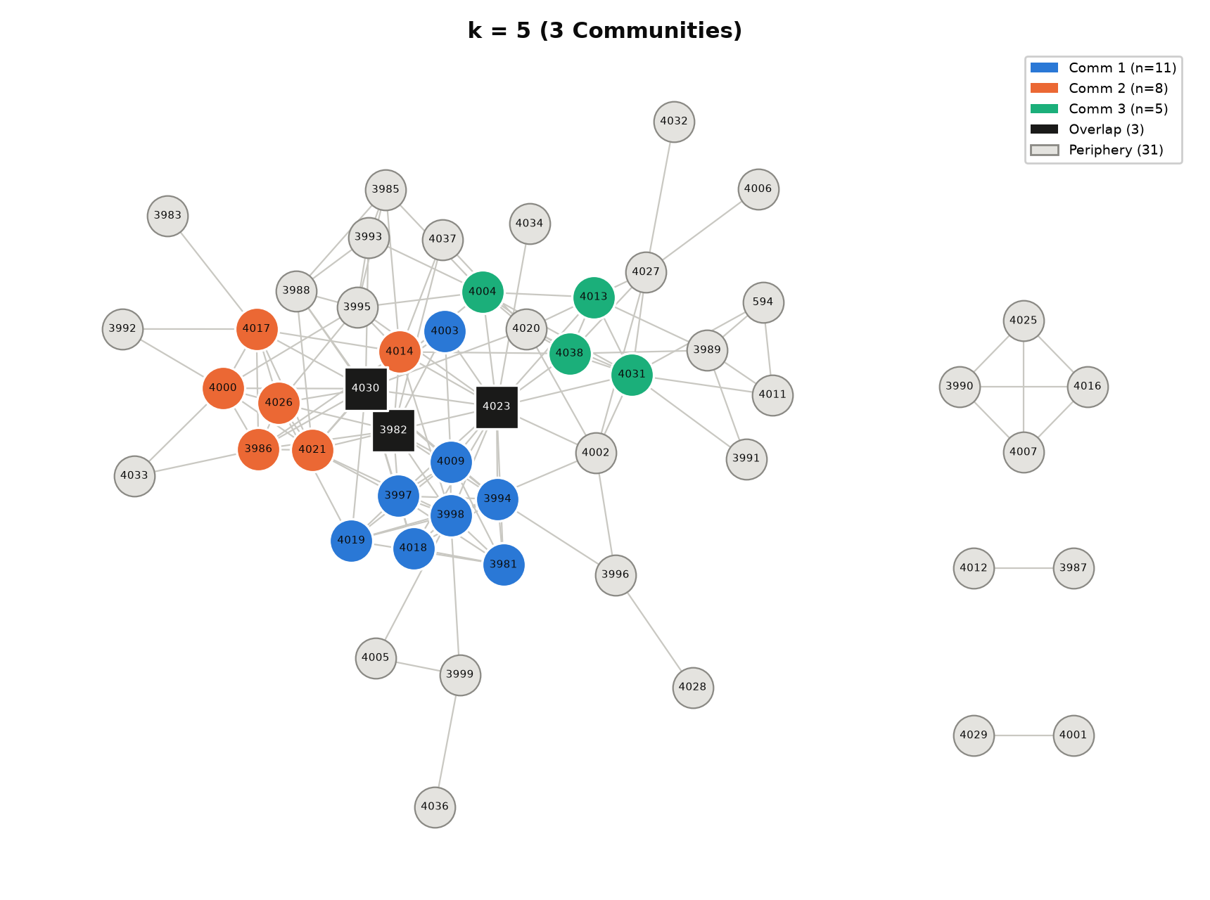

Conclusion
Thus, the experiment successfully implemented the Clique Percolation Method on real Facebook data for audience segmentation, and the step-by-step implementation matched the NetworkX result at k = 3, 4, and 5. At k = 4, it found 4 segments of 18, 8, 5, and 4 users, with 3 bridge users (3988, 4004, and 4023) and 20 periphery users. Compared with the circles defined by users, one segment matched a circle exactly (Jaccard similarity 1.00) and another closely (0.67), while the two largest segments spanned several circles (0.22 and 0.20). The method therefore identified segments, seed influencers, and bridge users that can support a targeted marketing campaign.

